# PYTHON WORKSHEET – WORKSHEET 4

## Q1 to Q8 have only one correct answer. Choose the correct option to answer your question.

1. Which of the following function is used to determine the length of a string in python?
   1. length() B) len()

C) strlen() C) stringlen()

**ANS: B) len()**

1. Python is?
   1. compiled B) interpreted

C) compiled then interpreted D) none of these

**ANS: B) interpreted**

1. What will be the output of the following? a = [1,2,3,2,1]

a.pop(2) print(a)

A) [1,3,2,1] B) [1,2,2,1]

C) [1,2,3,1] D) [1,3,1]

ANS: **B) [1,2,2,1]**

4. If alist = [10,20,30,40,50,60], then alist[ : : -3] = ?

A) [40,30,20,10] B) [30,20,10]

C) [60,30,10] D) [60,30]

ANS: D) [60,30]

1. Which of the following will give the reverse of list ‘a’: A) a[-1:0] B) a[-1:-4]

C) a[ : :-1] D) a[0:-1:-1]

**ANS: C) a[ : :-1]**

1. If a = True, b = False and c = True. Then what will be the output of following code:

if not a or b: print("Eena")

elif not a or not b and c: print("Meena")

elif not a or b or not b and a: print("Deeka")

else:

print("Domniqaa")

* 1. Eeena B) Meena

C) Deeka D) Domniqaa

**ANS: B) Meena**

1. What is the output of the following?

print([x+y for y in [“Hello ”, “Adios ”] for x in [“World ”, “Python ”]])

* 1. [“Hello World ”, “Hello Python ”, “Adios World ”, “Adios Python ”]
  2. [“Hello World ”, “Adios World ”, “Hello Python ”, “Adios Python ”]
  3. [“World Hello ”, “Python Hello ”, “World Adios ”, “Python Adios ”]
  4. [“World Hello ”, “World Adios ”, “Python Hello ”, “Python Adios ”]

**ANS:C) [“World Hello ”, “Python Hello ”, “World Adios ”, “Python Adios ”]**

1. Str1 = “Hello Python”. What will be the output of : print(str1.find(‘o’)) A) 4 B) 4,10

C) 5,11 D) 5

**ANS: A)4**

## Q9 and Q10 have multiple correct answers. Choose all the correct options to answer your question.

1. Which of the following is(are) correct method(s) to join two lists l1 and l2?
   1. l1+l2 B) l1.append(l2)

C) append(l1,l2) D) l1.extend(l2)

**ANS: A) l1+l2**

**D) l1.extend(l2)**

1. s = “pyworld”. Select all of the following which give same results? A) s[0]+s[-1] B) s[ : : -1][-1] + s[len(s)-1]

C) s[ : : -6] D) s[ : : -1][ : : -6]

**ANS:** **A) s[0]+s[-1]**

**B) s[ : : -1][-1] + s[len(s)-1]**

**D) s[ : : -1][ : : -6]**

## Q11 to Q13 are subjective questions, answer them briefly

1. Differentiate between a compiler and an interpreter? Which of them is used in python language?

We write a program using high level language. A high-level language is something which is understandable by human it is also called the source code but a machine can’t understand these high level language, it can only understand 0 and 1 which is also called as machine code. So, the entire source code is converted into machine code for effective execution.

The conversion of high level language to a machine level language is obtained by compiler or interpreter. The below are the key difference between a compiler and an intrepreter

|  |  |
| --- | --- |
| COMPILER | INTERPRETER |
| It read the entire program and convert them into machine code at once. | It read each statement of the program and convert them into machine code one by one |
| It takes large amount of time to analyze but the overall execution time is faster as compared to that of an interpreter. | It takes less time to analyze but the execution time is slow as compared to that of a compiler |
| It generates intermediate object code which require further lining and it also consumes extra memory | It doesn’t generate any intermediate object code so it is memory efficient |
| It is use in languages like C, C++, Java | It is use in high level languages like Python, Ruby, JavaScript. |

1. What is the purpose of PYTHONPATH environment variable?

The **PYTHONPATH** is an environment variable which can be used to add extra directories where the python will search for modules and packages.

The main reason to set a python path is to maintain a directories of custom python library which will not be found in the default location.

1. How will you remove all the leading and trailing whitespaces in a string in python? Give one example.

To remove the trailing and leading white space in a string the python inbuilt function **strip()** can be used.

Example;

**Input:**

string=' There is only one thing that makes a dream impossible to achieve: the fear of failure. '

print('String with whitespaces =\n',string)

print('\nAfter Removing Trailing and leading Whitespaces=\n',string.strip())

**Output:**

String with whitespaces =

There is only one thing that makes a dream impossible to achieve: the fear of failure.

After Removing Trailing and leading Whitespaces=

There is only one thing that makes a dream impossible to achieve: the fear of failure.

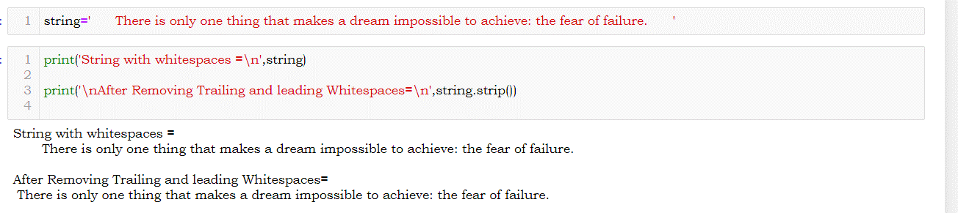

## Q14 and Q15 are programming questions. Answer them in Jupyter Notebook.

1. Write a python program to represent a user entered number in expanded form. For eg: user_input = 12345

Output = 1*10000 + 2*1000 + 3*100 + 4*10 + 5*1

1. Write a python program to determine whether the number entered by the user is an Armstrong number or not?

Jupyter notebook link: